**Assignment 5 - : Git**

**GitFlow Workflow architecture is created :**

1. Master branch
2. Develop branch
3. Feature1 branch
4. Feature2 branch

List of commands used:

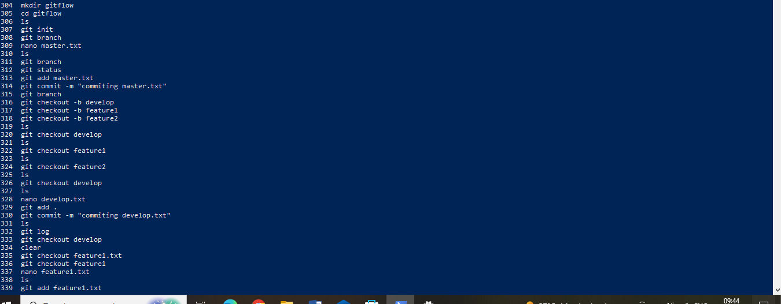

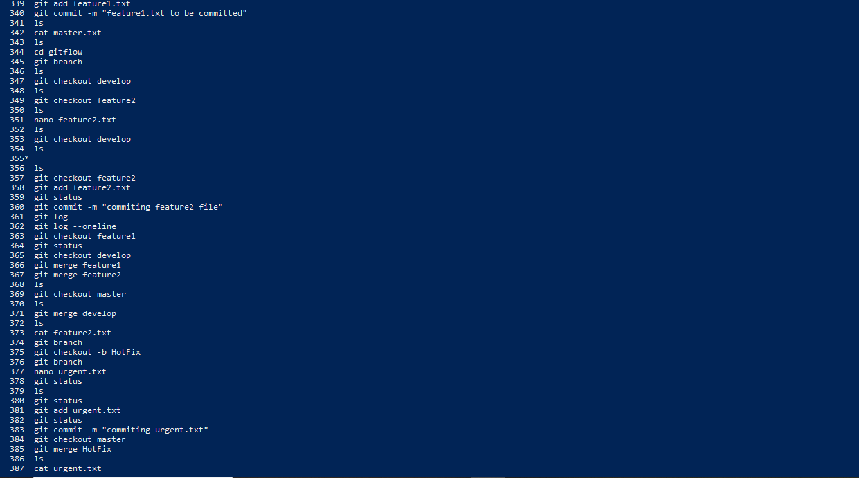

Merging the feature1 and feature2 branches with develop branch.

Then merging the develop branch with the master branch – as per GitFlow WorkFlow architecture.

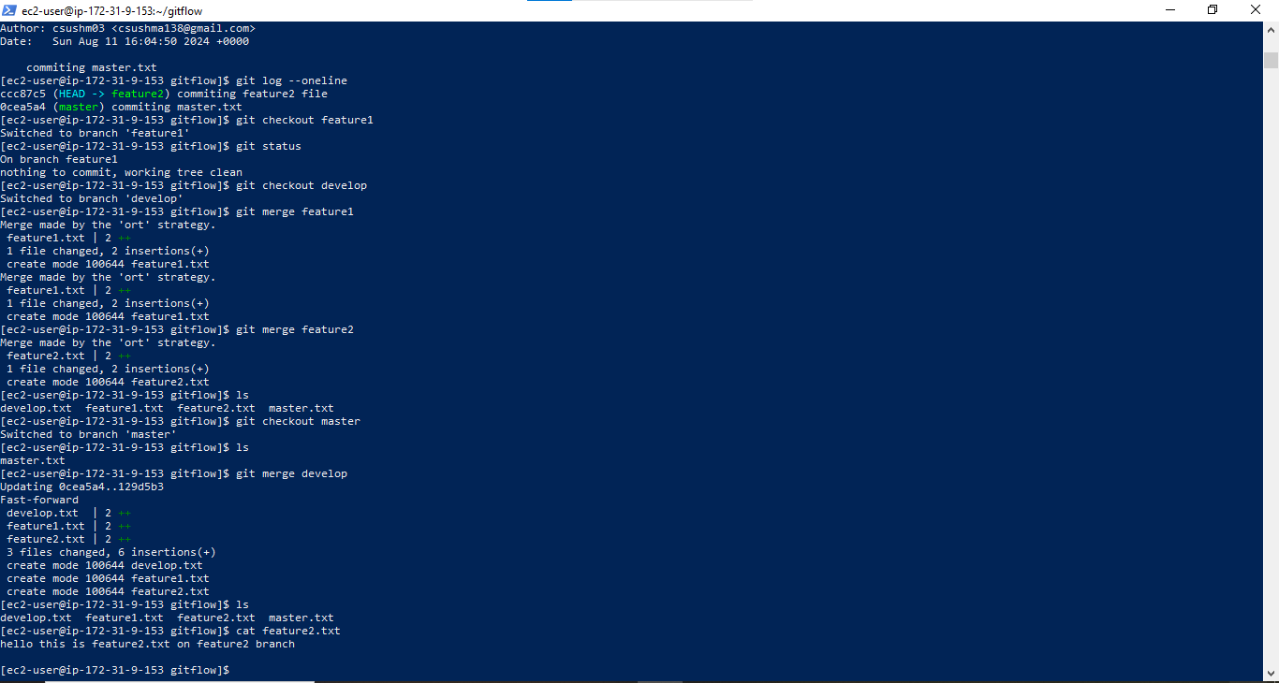

Creating the HotFix branch with urgent.txt (to fix any errors arising on production server in a quick manner) and merging it with master branch :

